14.2

A.

N=6

Xi= -1,+1,-3,+3,-5,+5

P(Xi)= each one is equally likely

I(Xi)= same for all since same probability

B.

-5 is transmitted none of the time

I(xi)=

14.14

Error probability of 4 level is with noise power of .01, due to the lose noise power almost no errors happen

14.16

A.

I(xi)=

B. see picture below

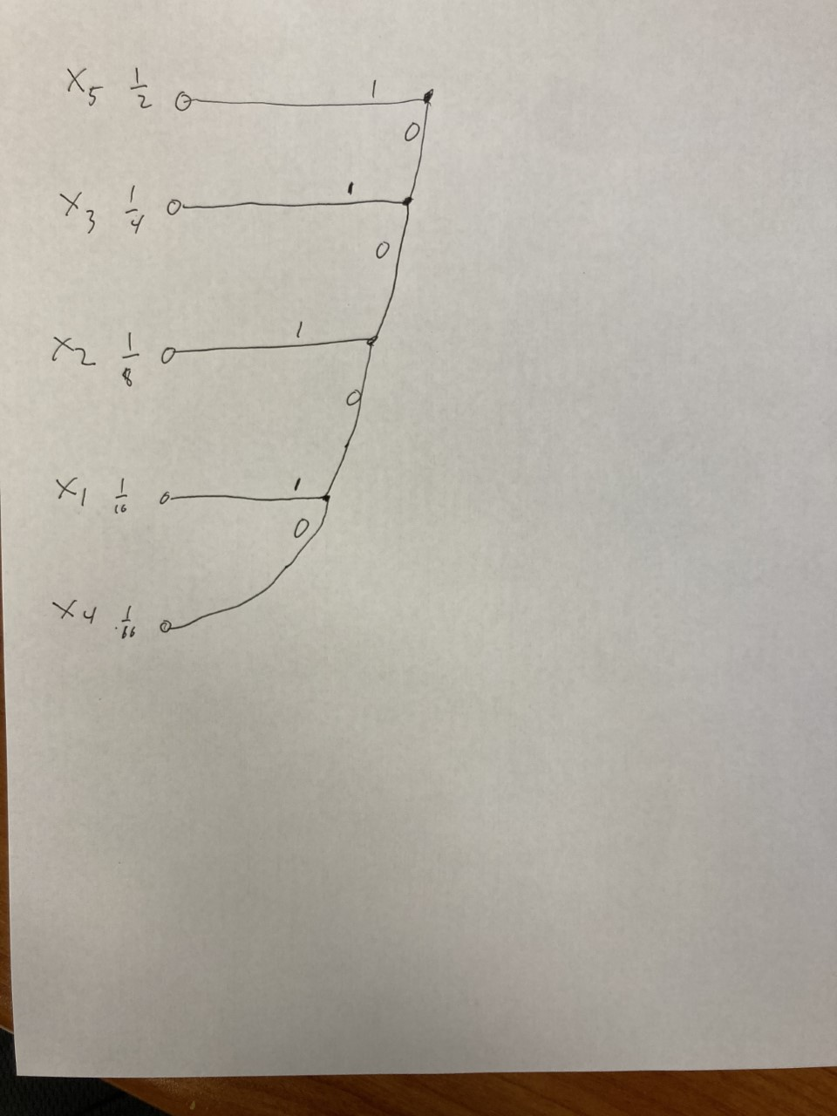

C. x1 corresponds to 0001

x2 corresponds 001

x3 to 01

x4 to 0000

x5 to 1

D.

Efficiency

E. 10 bits are required with naïve encoding

Efficiency